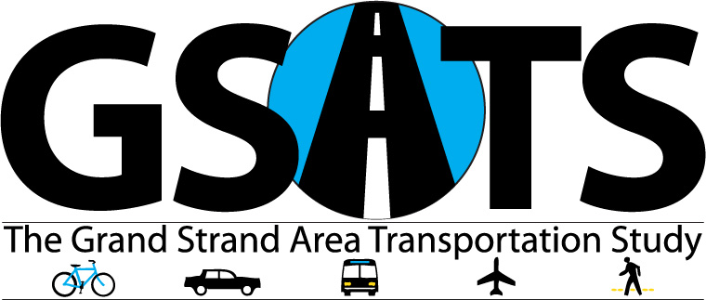

Myrtle Beach⦁N.Myrtle Beach⦁Surfside⦁Conway⦁Georgetown⦁Atlantic Beach⦁Briarcliffe⦁Pawleys Island⦁Calabash⦁Carolina Shores⦁Shallotte⦁Holden Beach⦁Sunset Beach⦁Ocean Isle Beach⦁Varnamtown

**AGENDA rev**

**GSATS**

**TECHNICAL COORDINATING COMMITTEE**

**Wednesday, July 17, 2024**

**Ocean Isle Beach Town Hall**

**10:30 AM**

1. Ethics Awareness & Conflict of Interest Reminder Mark Hoeweler

In accordance with the State Government Ethics Act, it is the duty of every Committee member to avoid conflicts of interest. Does any Committee member have any known conflict of interest with respect to any matters coming before the Committee today? If so, please identify the conflict and refrain from any participation in the particular matter involved.

1. Introductions Mark Hoeweler
2. Meeting Summary from 04/10/24 Mark Hoeweler
3. Boundary Vote Update Chairman Eccard
4. NCDOT Projects Update Michelle Howes
5. NCDOT TPD Update Behshad Norowzi
6. FTA Program Management Plan Elizabeth Tucker action item
7. MTIP Amendment for Statewide Projects Elizabeth Tucker action item
8. SPOT 7.0 Local Input Point Assignment Tom Dobrydney action item
9. Adjourn